|  |
| --- |
| colored transparent rectanglecolored rectangle  2023  Annual Report |

|  |
| --- |
| Southwestern Minnesota Opportunity Council |

|  |  |
| --- | --- |
| Community Action changes people’s lives, embodies the spirit of hope, improves communities and makes America a better place to live. We care about the entire community, and we are dedicated to helping people help themselves and each other. |  |

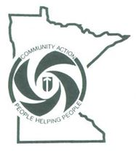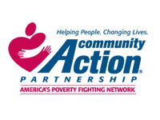

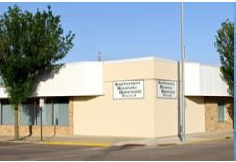

|  |  |  |
| --- | --- | --- |
| Executive Summary – 2023 in Review Southwestern Minnesota Opportunity Council, Inc. (SMOC) is a non-profit Community Action Agency,  serving the needs of low-income persons in Southwestern Minnesota, specifically in the counties of  Nobles, Rock, Murray, and Pipestone.  Although these counties receive most of our attention, SMOC  does provide specific program offerings in as few as one, and in as many as 15 counties.  **The mission of the SMOC is “Strengthening our communities through opportunities and service.”**  A huge thank you is extended to SMOC’s staff who keep our organization functioning at a highly  professional level every day. We wish to thank every one of them for their dedication to a job well  done.SMOC has approximately 60 full-time and 40 part-time staff  It is also important to recognize our Board of Directors, the decision-makers who, because of their  passion for serving those in need, give generously of their time and attention to ensure unmatched  quality and compassionate services. | | |
| Responding to community needs has always been central to the work we do at SMOC, and this past year has certainly demonstrated that core value. In 2023, we continued to operate all of our standard programs and services, sometimes in new ways, but always with the goal of providing consistent service to our program participants.  We may not know what challenges lie ahead for SMOC, but we know that with the talented team we have, we will be well-equipped and ready to respond.  Darci Goedtke, Executive Director | | |
| Child Care Aware   * Child Care Aware serves **nine counties** in Region 8: Cottonwood, Jackson, Lincoln, Lyon, Murray, Nobles, Pipestone, Redwood and Rock. Our regional program is included in the West/Central Child Care Aware District. * Region 8 continues to experience a net loss of programs (350 family child care programs in 2021 vs 284 family child care programs in 2023. **Two Child Care Centers were opened:** one in Cottonwood County and one in Redwood County. Consistent enrollment and staffing shortages remain challenges for the child care industry. Maintaining enough children aged 3-5 on a regular basis remains an issue. Child care programs are not able to compete with “Free” preschool options (with many expanding to younger ages.) * Consultation, coaching, and technical assistance is provided to 284 family child care providers, 14 child care centers, and 12 community preschool programs operating in Region 8. There are also 67 public school-based early childhood programs located in the 34 school districts we work with in addition to Head Start / Early Head Start programs/sites. * 14 Child Care Center Directors receive advocacy, training, grant, resource, policy, and support information through technical assistance and monthly Region 8 Child Care Center Director meetings. * We added a Child Care Start-up and Retention Navigator to the Child Care Aware team to support the development and retention of child care options in Region 8. * Parent Aware Quality Coaches provided coaching, technical assistance, and guidance to preschool, family child care providers and child care centers in Region 8 involved in Parent Aware, Minnesota’s Quality Rating System. * 137 early childhood programs in Region 8 are Parent Aware rated. These programs are supported by the Parent Aware Coaching staff during each six-month Full Pathway to Rating and Building Quality cohort. * Virtual Parent Aware coaching and Learning Community opportunities are offered in addition to in-person services. This makes it possible to bring programs from our 18 county West Central Child Care Aware District together for support and education. |  |  |

|  |
| --- |
| Programs in Review |

|  |  |
| --- | --- |
| Early Learning Scholarships *Early Learning Scholarships in the amount of $2.6 million were awarded to 258 children attending child care centers, family child care,  and preschool programs in Region 8.  *54 children aged out 09/01/2023 (eligible for Kindergarten.) | *Children’s scholarship award amounts were increased 7/1/2023:   * $5,000 per child to attend a child care program participating in a Full-Pathway to Rating Cohort * $6,000 per child / per year to attend a child care program with a One or Two-Star Parent Aware Rating * $9,000 per child / per year to attend a child care program with a Three-Star Parent Aware Rating * $12,000 per child / per year to attend a family child care program with a Four-Star Parent Aware Rating |

#### **Energy Assistance:**

#### 2491 Processed Applications

#### 932 Crisis Applications

#### 129 Energy Related Repair Applications

#### EAP Administrative Costs = $105,294.47

#### Outreach & Responsive Costs = $58,477.69

## Senior Community Service Employment Program:

**24 participants**

**19 host sites**

**$35,048.28 in-kind dollars for supervisors**

**$98,228.25 in Senior Employment wages**

## Homemakers:

54 Clients

10 Homemakers

$47,913.11 in Homemaker wages

**Minnesota Housing:**

**\*1 Rehabilitation Loan equaling $28,262.00**



# MN Housing Vision

All Minnesotans live and thrive in a stable, safe and accessible home they can afford in a community of their choice.

Family Planning

Family Planning was very busy in 2023. Thanks to our funding, we were able to provide services to persons whom often would be unable to obtain without our services. The data below reflects the work completed in 2023.

Through our outreach and networking, we were able to secure 4 providers, 2 casual Nurse Practitioners were hired as SMOC employees and 2 others were contracted with SMOC through Avera Health-Worthington and CCM-Montevideo. We are grateful for those partnerships in an effort to continue services.

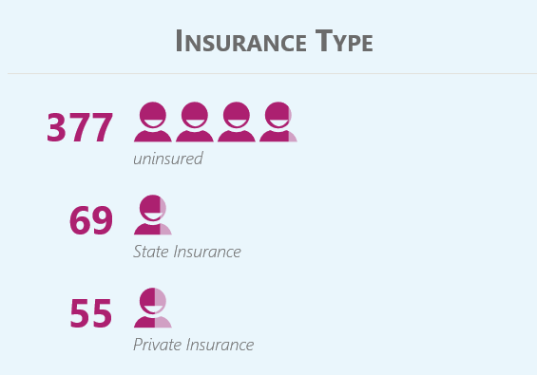

330 clients were non-English speaking

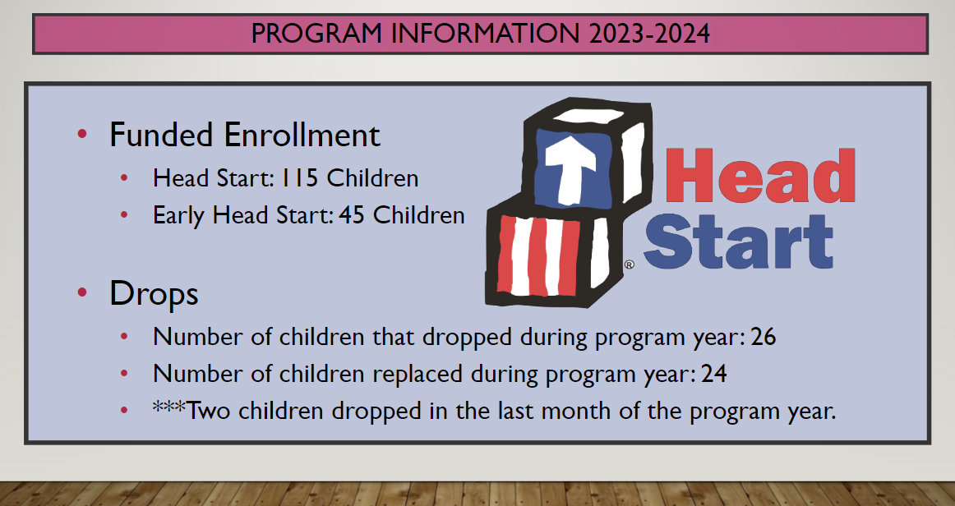

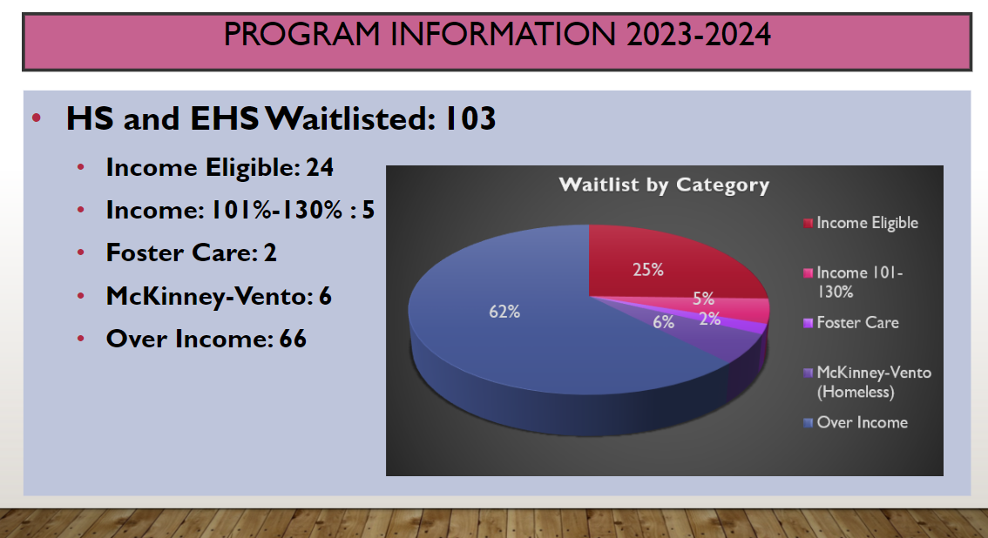

*\*\*See SMOC Head Start Annual Report and Program Data 2023 -2024 for more information*

Prairieland Transit System

2023 Stats for Prairieland Transit System

* **20 routes** were provided in Nobles County with two Nobles County Heartland Express buses.
* Each of the **fourteen communities in Nobles County** was served **five times per week**.
* The Worthington City Bus Route provided route service in the City of Worthington with **one dedicated bus**.
* **515 rides** were provided to residents of Worthington on the Worthington City Bus.
* **3,849 rides** were provided to residents of Nobles County with the Nobles County Heartland Express route buses.
* **17,906 rides** were provided within the City of Worthington-by-Worthington Dial-A-Ride buses.
* **7,969 hours** of public transportation services were provided.
* **81,844 miles** were driven by Prairieland Transit System.

Nobles County Heartland Express

Worthington Dial-A-Ride

Worthington City Bus

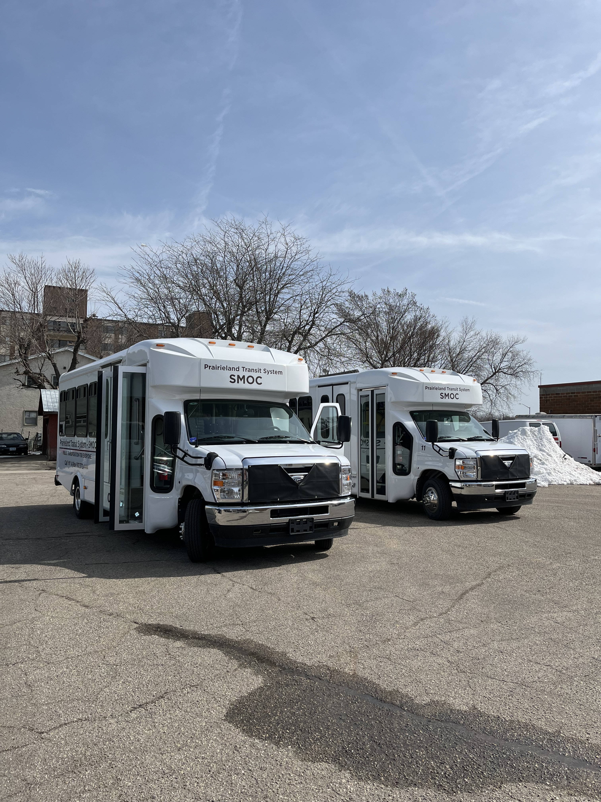

For more information:

Southwestern Minnesota Opportunity Council, Inc.

1106 3rd Avenue | PO Box 787

Worthington, MN 56187

Call 507-376-4195 or

toll free 800-658-2444

Head Start: 507-727-1759

Fax: 507-376-3636

